GREAT SYMBOL OF PYTHAGORAS
190 {d,
Figure 12. Pythagoras.
From Pierre Mussard, Historia Deorum Fatidicorum (1675).

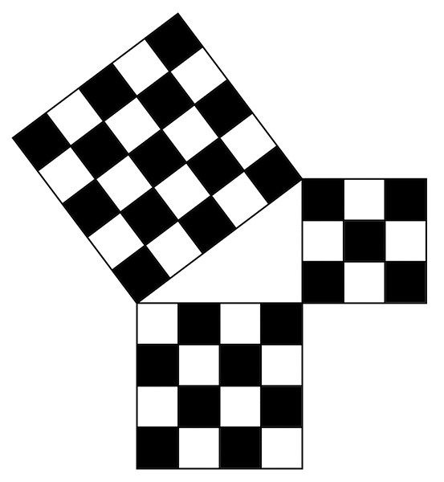

Sheet178
GREAT SYMBOL OF PYTHAGORAS
THE 47TH PROBLEM - Euclid
The 47th problem is this:
In every right-angled triangle the sum of the squares of the base and
perpendicular is equal to the square of the hypotenuse, i.e. the line
which connects the ends of the other two sides.
If the base be 3 measures and the perpendicular 4, of the same length each,
the hypotenuse will be 5. If it be not, the base and perpendicular form either
an obtuse or acute angle, and the triangle is not right-angled.
I have seen several large sheets of paper, covered with intricate diagrams,
largely intended to illustrate the 47th Problem, in all of which (and they were
most elaborately and with vast labor drawn), the triangle supposed by its author to
represent that problem was an obtuse angle, of at least 120 degrees, instead of go,
(which is a right angle): and yet the geometrician in question, who would"illustrate"
his figures in the discourse of hours, without communicating to us here a single
lucid idea, simply because he had none, in regard to his fantastic figures, has estab-
lished a special Masonry of a Degree or two, in which his diagrams were intended
to be used; and is a fluent writer for Masonic periodicals, a Master in Israel.
If a Mason is carrying up the corner of a building, and wishes to know
whether it is square, he will measure 3 feet from the corner one way and 4 the
other. If then a line drawn from the termini is more or less that exactly 5 feet, he
has not made a square corner. This is a practical use of the problem or theorem.
It is said that when Pythagoras discovered this problem, he sacrificed a hun-
dred oxen. Why? As a mathematical theorem it is of no more importance or interest
than fifty or seventy five others in Euclid; and of much less than most of them.
em} 191
Sheet179
+ THE SYMBOLISM OF THE BLUE DEGREES OF FREEMASONRY +
The explanation is a simple one. He styled it great symbol:Mathematical
theorems are not ordinarily symbols. He never styled any other theorem a
symbol, great or small. A circle, a triangle, a square, a cube are symbols, but I
do not know that any other Problem has ever been so styled. He did not call
or consider the figure, the right-angled triangle, itself, as a figure, a "symbol."
Only one which represented the numbers 3, 4, 5 was a symbol for him. Its
symbolism consisted in its representation of these Numbers; and he called
it a symbol, and used it as such, because he could, by means of it, express
to the adepts and entrust to his pupils some great philosophical or religious
truth or creed, by the use of the measures 3 and 4, the sum of which is the
always sacred number 7.
The square of a number is produced by multiplying the number by itself. The
cube of a number is obtained by multiplying its square by the original number.
The square of 3 is 3 times 3, 9; the square of 4 is 4 times 4, 16; the square of 5 is
5 times 5, 25; 3 x 3 = 9; 4 x 4 = i6; and 5 x 5 = 25, and 9 + 16 = 25.
Formerly every Masonic square represented the base and perpendicular,
one being 3 measures in length, and the other 4. But I have seen in the Monitor
used by all the Lodges in a State, three squares, each of different dimensions
and neither of them correct.
Formerly, also, the altar-lights of the Lodge represented this theorem, two
on the East side of the altar, North and South of each other, and 3 feet apart,
and a third due West of the North light and 4 feet from it. This was in the
Apprentice's Lodge. In the Master's Lodge there was a group of three lights at
each of the same points, making 3 times 3.
It is curious how continually the number 7 is forced upon our notice in
both the Old and New Testaments. The 6 days of creation and one of rest,
the 7 sprinklings and purifications again and again prescribed, the seven
churches, seven seals, seven trumpets of the Apocalypse, are a few out of
the great number of instances.
192, ,fra5
Sheet180

